Inception phase
Inception is about understanding the project scope and objectives
- Understand what to build. Determine an overall vision, including the scope of the system and its boundaries. Identify the stakeholders: who is interested in this system and what are their success criteria?
- Identify key system functionality. Decide which requirements are most critical.
- Determine at least one possible solution. Assess whether the vision is technically feasible. This may involve identifying a candidate high level architecture.
- Understand the high level estimate for cost, schedule, and risks associated with the project.

Potenciais tarefas e ações: (GUIÃO // BARRACA)
- Interação com os STiC de forma a estudar a estrutura atual da rede da universidade, equipamentos utilizados e modelo de gestão
- Planeamento de uma estrutura de software para um portal de Self Service apoiado por SDN
- Desenvolvimento de componentes que permitam a representação visual dos equipamentos geríveis por um sujeito e do seu estado (routers, switches, computadores) ← ?
- Adição de funcionalidades para a gestão remota de dispositivos
- Adição de adaptadores que permitam gerir dispositivos remotos

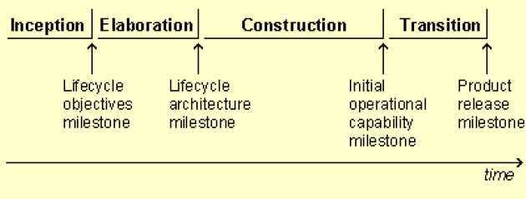

TODO (DL 24/02):
- Project presentation
  - Context
  - Problem
  - Goals
  - Tasks
  - Expected results
  - Related work (draft version)
- Project calendar
  - Tasks list (?)
  - Project schedule: project due date determined by exams calendar; be aware of the Students@DETI event
  - Milestones (4): number and short description (< 120 chars)
    - [24/02/2020] M1: presentation of the life cycle objectives and calendar for the project.
    - [09/03/2020] M2: presentation of the lifecycle architecture; the milestone is achieved when the architecture has been validated.
    - [20/04/2020] M3: prototype; mid-term presentation with supervisors; peer evaluation.
    - [25/05/2020] M4: project presentation; all functionality has been developed!
  - Deliverables: things the project needs to deliver (e.g., software packages and reports)
- Communication plan
  - Project website (codeUA / Github / Redmine / … )
    - Project plan
    - Reports and presentations
    - Role and list of activities by team member
    - Repository (Git, Svn, Private (team) information
    - Give access to the supervisors and course instructors
- Assignments by team member
  - [...]

- Project presentation (week 3):
  - context, problem, goals, tasks, expected results, related work, calendar, communication and assignments by team member

